LAB 7

Upload your solution from Google Classroom until 31 March 2020, 17:00.

Write a program with priority queue for public transportation management system.

The system has one bus, three bus stations (B1, B2, B3), and many passengers (max 1000).

B1 is the first bus station, B2 is the second one and B3 is the last. Passengers can get on the bus from the bus stations B1 and B2. But all passengers have to get off the bus at the last bus station B3.
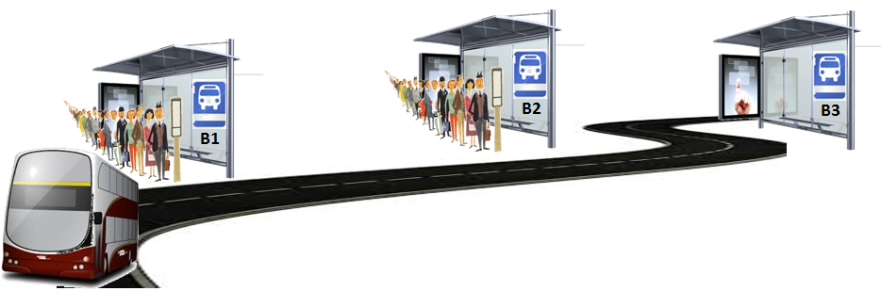

Bus design permits a full 8 passengers to travel in comfort with ample leg room on both sides of the aisle. Hence, maximum 8 passengers can travel on the bus.

Passengers have the following attributes: age and type (student or normal). The passengers, who are 65 years old or older, don't have a passenger card, because free public transport is available for everyone 65 years old and over. If the passenger is a student, the system should decrease 1 TL from the card for the journey; else the system decreases 2 TL.

In order to get on the bus, passengers enter into the queue at the bus stations B1 and B2. The passengers 70 years of age and over have priority, they should travel first.

The passenger information should be read from a text input file (c:\\data.txt). The first record must be inserted into the related priority queue, and then the second record must be inserted and so on. When a passenger 70 years or older is coming, the order in the queue must be updated.

After all passengers in the input file are added into the queues, the bus journey is started. If the bus can’t transport all the passengers at the bus stations, it comes again for the remaining passengers in the next tour. It is required from the application to print the passengers at the bus stations B1 and B2 at each tour. The program should also display the overall income from the bus.

File Format:
ID Station Age Type

Example Input File:
1 B1 30 normal  2 B1 70 normal  3 B2 20 student  4 B1 18 student  5 B1 80 normal  6 B1 75 normal  7 B2 15 student  8 B2 65 normal  9 B1 29 normal  10 B1 74 normal  11 B2 19 student  12 B1 25 student  13 B1 71 normal  14 B1 32 normal  15 B1 76 normal  16 B2 22 student  17 B1 21 student  18 B1 82 normal  19 B1 73 normal  20 B1 28 normal  21 B1 68 normal  22 B1 55 normal  23 B1 42 normal  24 B2 51 normal  25 B1 37 normal  26 B1 79 normal  27 B2 75 normal  28 B1 23 student  29 B1 67 normal  30 B2 17 student  31 B2 29 normal  32 B2 80 normal  33 B2 20 student |  | Priority Queue B1  Front  2 B1 70 normal  5 B1 80 normal  6 B1 75 normal  10 B1 74 normal  13 B1 71 normal  15 B1 76 normal  18 B1 82 normal  19 B1 73 normal  26 B1 79 normal  1 B1 30 normal  4 B1 18 student  9 B1 29 normal  12 B1 25 student  14 B1 32 normal  17 B1 21 student  20 B1 28 normal  21 B1 68 normal  22 B1 55 normal  23 B1 42 normal  25 B1 37 normal  28 B1 23 student  29 B1 67 normal  Rear | Priority Queue B2  Front  27 B2 75 normal  32 B2 80 normal  3 B2 20 student  7 B2 15 student  8 B2 65 normal  11 B2 19 student  16 B2 22 student  24 B2 51 normal  30 B2 17 student  31 B2 29 normal  33 B2 20 student  Rear

After Tour 1 After Tour 2
Priority Queue B1  Front  26 B1 79 normal  1 B1 30 normal  4 B1 18 student  9 B1 29 normal  12 B1 25 student  14 B1 32 normal  17 B1 21 student  20 B1 28 normal  21 B1 68 normal  22 B1 55 normal  23 B1 42 normal  25 B1 37 normal  28 B1 23 student  29 B1 67 normal  Rear | Priority Queue B2  Front  27 B2 75 normal  32 B2 80 normal  3 B2 20 student  7 B2 15 student  8 B2 65 normal  11 B2 19 student  16 B2 22 student  24 B2 51 normal  30 B2 17 student  31 B2 29 normal  33 B2 20 student  Rear |  | Priority Queue B1  Front  21 B1 68 normal  22 B1 55 normal  23 B1 42 normal  25 B1 37 normal  28 B1 23 student  29 B1 67 normal  Rear | Priority Queue B2  Front  27 B2 75 normal  32 B2 80 normal  3 B2 20 student  7 B2 15 student  8 B2 65 normal  11 B2 19 student  16 B2 22 student  24 B2 51 normal  30 B2 17 student  31 B2 29 normal  33 B2 20 student  Rear
After Tour 3 After Tour 4
Priority Queue B1  Front  Rear | Priority Queue B2  Front  3 B2 20 student  7 B2 15 student  8 B2 65 normal  11 B2 19 student  16 B2 22 student  24 B2 51 normal  30 B2 17 student  31 B2 29 normal  33 B2 20 student  Rear |  | Priority Queue B1  Front  Rear | Priority Queue B2  Front  33 B2 20 student  Rear

After Tour 5
Priority Queue B1  Front  Rear | Priority Queue B2  Front  Rear

Overall Income = 28 TL

--------------------------------------------------------------------------------

Notes:

1- In your program, you can use priority queue as you want.
Don’t use arraylist or stack.

You can use a string array for split operation.
After transfering elements from the string array to the priority queues, the main solution must be made on the priority queues.

2- Please use the priority queue class which is given in the course power point slides.
Don’t add a new method into the priority queue class.

3- Don’t use ENIGMA or any other extra library.

4- Send only *.java files.
File name example: 2015510012_Ali_Tas.zip

